**Bug Reports for InerG Test Web App**

* **Bug Report for TC-016**

1. **Summary:** Map image repeated on Zoom-out to Maximum extend
2. **Description:** When the map is zoomed out to the maximum extent, the map images repeat without a defined limit, which gives a wrong and unusable view of map.
3. **Steps to Reproduce:**
   1. Open the Inerg Test Web App URL.
   2. Scroll down to the map
   3. Zoom out to the maximum extent using the zoom control.
   4. Observe the map display.
4. **Expected Result:** The map zoom out should have a defined limit, displaying a complete view of the map area. The map images should not be repeated.
5. **Actual Result:** The map zooms out to Maximum extend, repeated the map images without apparent limit.
6. **Environment:**
   1. OS: Windows 11
   2. Browser : Google Chrome Version 132.0.6834.160
7. **Attachments:**

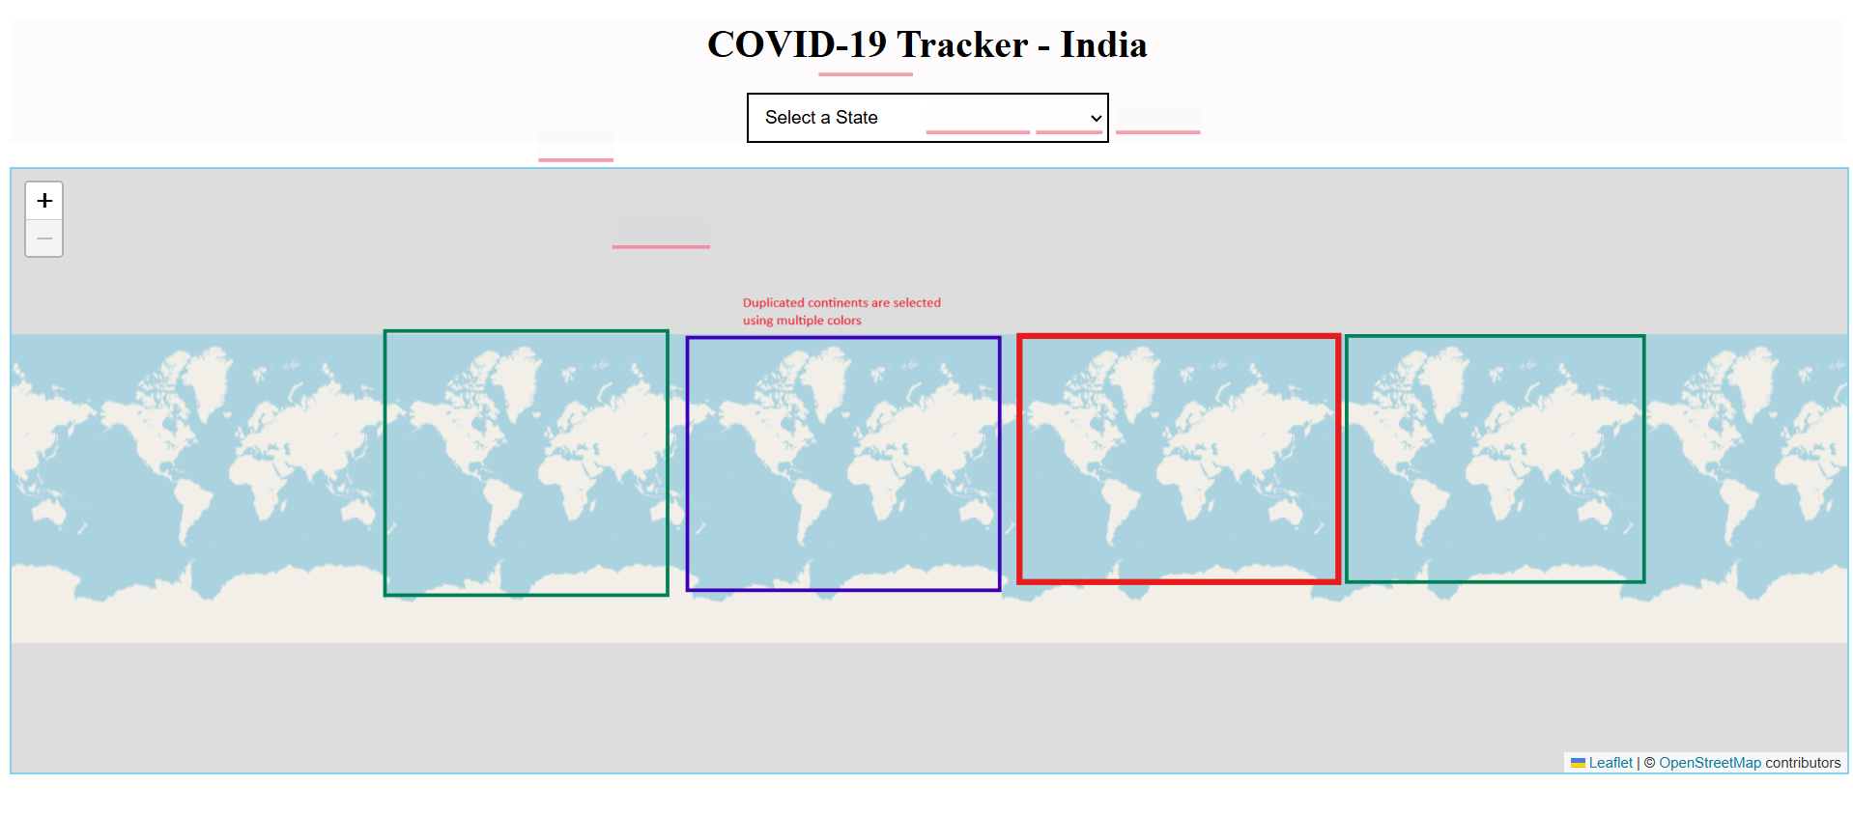

* **JIRA Bug Report for TC-020 and TC-021**

1. **Summary:** Wrong Distribution Data and Visualization of COVID-19.
2. **Description:** The pie chart depiction of COVID-19 distribution has multiple Bugs:
   * **Incorrect Slice for Total Cases:** The pie chart incorrectly includes "Total Cases" as a separate slice, distorting the proportions of other categories.
   * **Inaccurate Percentages:** The percentages displayed for Active Cases, Recovered, and Deaths do not match the calculated values based on the provided data.
3. **Steps to Reproduce:**
   * Open the Inerg Test Web App URL.
   * Select “Kerala” from the “Select a State” dropdown
   * In the upcoming page, navigate to the COVID-19 distribution pie chart.
   * Observe the pie chart for the slice distribution and percentage.
4. **Expected Result:**
   * The pie chart should display only the Active Cases, Recovered, and Deaths as separate slices. "Total Cases" should not be a slice.
   * The displayed percentages should be the same as following calculated values:
     + Active Cases: 23.60%
     + Recovered: 76.04%
     + Deaths: 0.34%
5. **Actual Result:**
   * The pie chart has "Total Cases" as a slice.
   * The displayed percentages are:
     + Active Cases: 11.8%
     + Recovered: 38%
     + Deaths: 0.17%
6. **Environment:**
   * + OS : Windows 11
     + Browser : Google Chrome Version 132.0.6834.160
7. **Attachments:**

